**CURRICULUM VITAE**

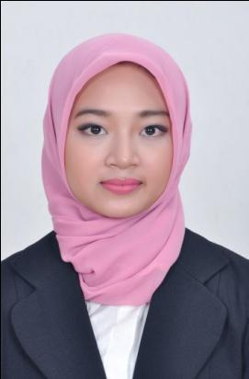

**Dinna Noorfika**

Sex : Female

Address : Bumi Panyawangan Jl Bungur III

no.4

Cileunyi, Bandung, Jawa Barat

Religion : Islam

Height : 163 cm

Weight : 50 kg

Marital Status : Single

Phone : +6287823009250

Email :  [dinna.noorfika@gmail.co](mailto:dinna.noorfika@gmail.com)m

Place & Date of Birth : Pemalang, 9 April 1992

GPA : 3.13

Thesis Title : Analyzing the Content of “Warm Bodies” Film

***EDUCATIONAL BACKGROUND***

|  |  |  |  |
| --- | --- | --- | --- |
| 2013-2014 | | S1/ Majoring in English Language | |
|  |  | **Sekolah Tinggi Bahasa Asing (STBA) YAPARI – ABA** | |
|  |  | **Bandung** | |
| 2010-2013 | | Diploma III/Majoring in English Language | |
|  |  | **Universitas Padjadjaran** | |
| 2007-2010 | | Sekolah Menengah Atas Negeri 3 | |
|  |  | Pemalang, Jawa Tengah | |
|  |  | | |
|  | ***ACTIVITY EXPERIENCE*** | | |
|  |  |  | |
| * Administration in Yayasan Saung Angklung Udjo (PKL) * Call Center OBC Telkomsel in PT Infomedia Solusi Humanika * Administration Pick Up and Posting Corporate in PT JNE | | |  | |
|  | |  | |

***ADDITIONAL SKILL***



**English Language** : Writing, Speaking, Reading (Active)

**Software** : Ms. Word, Ms. PowerPoint, Internet literateBe able to work in team and individual



Motivation to hardwork and progress

***HOBBY***



**Sport** : Jogging, basket



**Others** : Playing guitar, Reading, Watching movie