CURRICULUM VITAE
Muhamad Farid, SE.

 | Personal Data
Full Name Muhamad Farid  Place and date of birth Purwakarta, 13 Agustus 1994  Gender Man  Status Single |  | 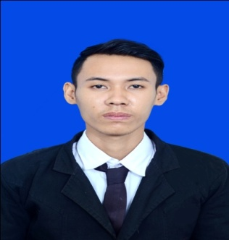 | Citizenship Indonesian  Religion Islam  Current Address Kp. Cibogo Peuntas RT/RW 17/09 Plered, Kab Purwakarta 41162  Telephone 081809016383

 | Education
Formal  2012 – 2016 STIE Ekuitas Bandung  Major Financial Management  Jl. PHH. Mustopa N0.31, Neglasari, Cibeunying kaler, kota Bandung |  |  | NON FORMAL  2015 Capital Market Scool (CMS)  Indonesia Stock Exchange (IDX)  2015 & 2017 Toefl/Toeic and Softskill Training  STIE Ekuitas Bandung
 |  | Organizational
OSIS 2010 – 2011 SMAN 1 SUKATANI
As Vice Chairman of the OSIS
The set of Management Students 2013 – 2015 STIE EKUITAS BANDUNG
As Chairman
Student CO-OP (KOPMA) 2013 – 2015 STIE EKUITAS BANDUNG
As Member
Young Indonesian Investor (IMI) 2016 – NOW
As Member – Student Organization of Bandung Investors

Work Experience
PT. MNC Securities. 2015 - 2016
As Financial Analys – A Financial company primarily engaged in capital market instruments.
Bakmie Parahyangan. • 2016
As SPV –Fast Food Company.

 |  | Ability
 | MS Office  Analys Rasio  Analys Fundamental |  | Communication  English Language  Japanese Language

