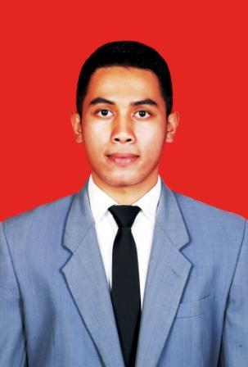
Erki Putra Perdana
Jl. KH. ADAM ZAKARIA 003 WONGKADITI BARAT KOTA UTARA, GORONTALO
+62-85-220-014-108 erki@ymail.com

“Young, decisive and self-motivated fresh graduate student, workaholic with self-motivated and good vision, Enthusiasm people who like an adventure and love the new think. Have a good team working and can work in under pressure situation, knowledge which develops my analytical skill, problem solver skills, sport and music holics.

…Education...
2009-2013 Universitas Padjadjaran

Literature Bachelor Degree
GPA 3.17 out of 4
…Achievementss
2015, Reward Achievement Tour to Thailand
2015, Reward Achievement Tour to Vietnam
2016, Reward Achievement To Korea
2016, Reward Achievement To New Zealand
2016, Achievement Target Reward Iphone 6 Plus
… Work Experienceg
2013 September - May, Astra Daihatsu, Division on Marketing, Jakarta
2014 June-Now Key Account Head Indomobil-Nissan Datsun, Jakarta
…Extra Cullicular Activity…
2016 Team Of Kerukunan Minang Tuah Sakato Gorontalo

2016 Basket Ball Vandalt’s Team

2013 Chief of IA SMAN 1 graduate 2009

2012-2013 Chief of IA SMAN 1 region Bandung

……Skillsss
Computer skills:
- Microsoft Office

Language skills:
- Bahasa Indonesia
- English
- Japanese

I hereby declare that all informations in this Curriculum Vitae is valid and by my good intention to be used by any parties need,
Personal Information
Fullname : | Erki Putra Perdana
Nickname : | Erki
Date of Birth : | 18th April 1991
Place of Birth : | Padang Panjang
Height/Weight: | 176cm / 70kg
Religion : | Moslem
Nationality: | Indonesia
Hobbies : | Basketball, Music ,Reading, and adventure
Sincerely yours

Erki Putra

