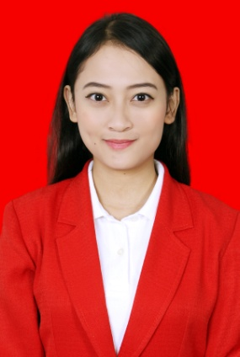Name : Astrid Alfina Primatasya

Place/Date of Birth : Bandung, 25 March 1995

Sex : Female

Marital Status : Single

Religion : Moslem

Address : Jl. Bahagia Permai IX No. 13, Buah Batu Bandung.

Phone Number : (+62)81221722040

Email : [astrid.alvina@yahoo.com](mailto:astrid.alvina@yahoo.com)

**Formal Education**

|  |  |  |  |  |
| --- | --- | --- | --- | --- |
| LEVEL | PERIOD | SCHOOL NAME | CITY | MAJOR |
| Kindergarten | 2000-2001 | TK Permata Ibunda | Bandung |  |
| Elementary School | 2001-2007 | SDN Karang Pawulang II | Bandung |  |
| Junior High School | 2007-2010 | SMP Negeri 34 | Bandung |  |
| Senior High School | 2010-2013 | SMA Negeri 5 | Bandung | Social Science |
| Bachelor Degree | 2013-2017 | Maranatha Christian University  GPA: 3.46 | Bandung | Faculty of Law |

**Organization Experiences**

|  |  |  |
| --- | --- | --- |
| YEAR | ORGANIZATION | POSITION |
| 2006 | Extracurricular Pramuka SDN Karang Pawulang II |  |
| 2009 | Extracurricular Cheerleader SMP Negeri 34 Bandung | Leader |
| 2012 | Extracurricular Cheerleader SMA Negeri 5 Bandung | Flyer |
| 2016 | Student Senate Faculty of Law Maranatha Christian University | Coordinator of Venture Funds Division |

**Working Experiences**

* December 2016 – January 2017 PT. Telekomunikasi Selular (Telkomsel)

(Jl. Taman Widya Chandra 2 No.52, Kuningan Bar., Mampang Prpt., Kota Jakarta Selatan, Daerah Khusus Ibukota Jakarta 12710, Indonesia.)

Contractual Counsel Division

**Academic Writing**

* Bachelor Thesis:

“ANALISIS YURIDIS IMPLEMENTASI ASAS KEWAJARAN SEBAGAI SALAH SATU PRINSIP *GOOD CORPORATE GOVERNANCE* DALAM PENGADAAN BARANG DAN JASA BADAN USAHA MILIK NEGARA (BUMN) MELALUI PENUNJUKAN LANGSUNG SEBAGAIMANA DIATUR OLEH PERATURAN MENTERI BUMN NOMOR: PER- 15/MBU/2012 TENTANG PEDOMAN UMUM PELAKSANAAN PENGADAAN BARANG DAN JASA BUMN DIKAITKAN DENGAN UNDANG-UNDANG NOMOR 5 TAHUN 1999 TENTANG LARANGAN PRAKTEK MONOPOLI DAN PERSAINGAN USAHA TIDAK SEHAT”

Total Score: A

**Skills**

* Language

|  |  |  |  |
| --- | --- | --- | --- |
| Language |  |  |  |
| English | Good | Good | Good |
| Indonesia | Native | Native | Native |

* Computer Literate

|  |
| --- |
| Microsoft Office |
| Adobe Reader |

**Seminars Attended**

* Seminar Mahkamah Konstitusi 2014
* Seminar Otoritas Jasa Keuangan (OJK) 2014
* Seminar Hak Kekayaan Intelektual 2014
* Seminar Masyarakat Ekonomi Asean (MEA) 2015
* Seminar TOTAL E&P INDONESIE 2016
* Seminar Ikatan Notaris Indonesia (INI Jabar) 2016