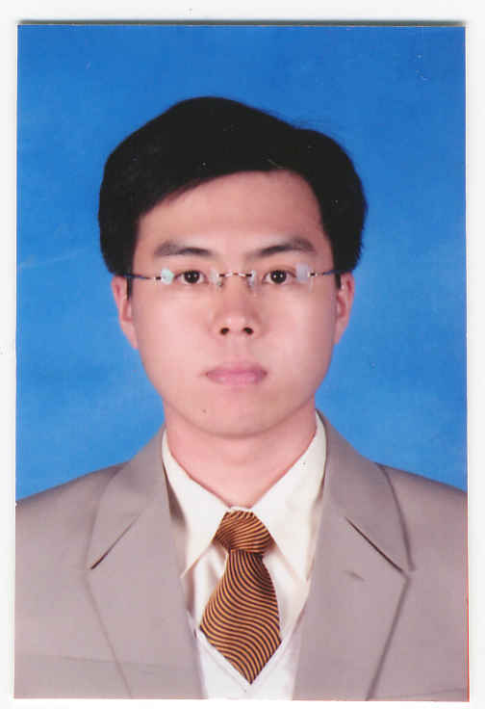

CURRICULUM VITAE

Yusup Sugianto, ST.

PERSONAL INFORMATION

Place/Date of Birth : Bandung / November 29th, 1982
Sex : Male
Religion : Christian
Marital Status : Married
Address : Jl. Minatu No.3, Lembang
Bandung – 40391
Contact Number : (022) 278-6165 / 0853-7199-9788
Email : yusup.sugianto@yahoo.com
yusup.sugianto82@gmail.com

EDUCATION

July 1988 – July 1994
Pancasila Government Elementary School.
July 1994 – July 1997
Christian Junior High School 4 BPK Penabur Bandung.
July1997 – July 2000
Christian General High School 2 BPK Penabur Bandung.
Aug 2000- Sept 2005
Electrical Engineering - Technical Faculty
Maranatha Christian University – Bandung
Thesis : Model of Two Dimension Egg Evacuation By Using MCS-51 MicroController and Infra Red Sensor.

ORGANIZATION, TRAINING, COURSES & SEMINAR

- One Day Seminar 'Application of Data Communication', 2002.
- One Day Seminar 'Carrier in IT', 2002.
- Management Trainee ‘PT. Indomobil Sukses Internasional Tbk’, 2007.
- Committee Chairman ‘Indoparts Family Gathering’, 2010.

WORK EXPERIENCE

April 2005 – April 2007
Electrical Staff
PT. Indotek Mitra Kurnia, Bandung
Responsibility :
- Responsible as Purchasing team for Procurement.
- Responsible for Electrical Project management.
- Responsible for Acrylic Project management.
.

July 2007 – October 2012
Product Development – Section Head
PT. Central Sole Agency (Indoparts), Jakarta
Responsibility :
- Responsible for product range expansion especially in Automotive parts.
- Identify potential working partners for tie-in with brand or conversion into network (co-branding).
- Manage inquires from potential suppliers.
- Conduct regular visit to dealer/workshop/partshop and provide consultancy on product (dealer visit).
- Manage feedback from dealer/workshop/partshop.
- Act as liaison in aspects of warranty processing, technical problem handling, etc.

- Implement Brand Building Campaigns/Event for the Market (including Aftersales Initiatives).
- Conduct Competitor Information Analysis (including Market & Latest Competitor Activity).
- Initiate and Support Project details and commercial info until Project Completion.
.

November 2012 – July 2014
Marketing Support – Dept. Head
PT. Indomobil Trada Nasional (Indomobil Nissan), Jakarta
Responsibility :
- Reporting directly to Sales & Marketing GM.
- Collect Report from Branches (Sales, Stock, Sales Program, Activity Plan, Marketshare, etc).
- Conduct Sales Analysis and Forecast from information gathered from dealers and manage gap fulfillment.
- Evaluating the basic competency standards of sales force in every dealers.
- Evaluating Dealers Sales Performance and make recommendations for improvement.
- Ensure that the physical environment of the dealer is in compliance to the standard at all times.
- Monitor and evaluate marketing effectiveness against divisional objectives and plan.
- Conduct Market Research and Competitive Analysis efforts as required.
- Co-ordinate market intelligent info and customer potential evaluation.
.

August 2014 – Oktober 2017
Branch Head
PT. Sumber Multi Jaya Nusantara (CST Tires), Bandung
Responsibility :
- Responsible for Branch Performance by Planning, Monitoring and Evaluating Sales Achievement, Area Covering and Customer Management to Achieve Company Sales Target.
- Determine Sales Strategic, Visiting Schedule and Sales Target for Maximum Sales Achievement.
- Monitoring and Evaluating Sales Achievement Continuously.
- Monitoring Debt Collection and Customer Due Payment.
- Review and make sure the Sales Order Preparedness for Delivery Process.
- Mapping Sales Area.
- Monitoring and Evaluating Market Demand and Competitor Movement.
- Analizing Market Needed and Arrange Sales Strategy.
- Doing another related task to Achieve the Sales Target.

TECHNICAL PROFICIENCY

- Software : Corel Draw, Sony Vegas, Photoshop.
- Application : Ms.Windows Office (Word, Power Point, Excel).
- Internet, E-mail.
- Language : English, Indonesia and Sundanese.

INTEREST

- Sports : Badminton, Bicycle, Swimming and Tennis.
- Automotive Field.
- Machinery.
- Reading.
- Travelling.

BIOGRAPHY

I am young professional with demonstrated combination of analytical and technical skills. My specialization ranges from Marketing Strategy (ATL, BTL, Sales Campaign). My expertise also covers Business Development and Market Inteligence activities. I’ve been exposed in various special project to improve sales result and to prepare forecasts.
I am effective team player with outstanding communication and interpersonal skills.
I am currently seeking full-time employment that is creatively challenging and can bring a long committed relationship.

