CURRICULUM VITAE (CV)

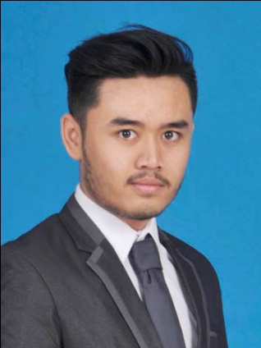Name : Muhammad Elfriandri Hendrayana.

Place of Birth : Bandung, 01 October 1996

Address : Sarijadi Flat K Lantai 2 no 13 Bandung. (Permanent)

Email : [elfriandri@sbm-itb.ac.id](mailto:elfriandri@sbm-itb.ac.id)

Cell Phone : 089605393211

GPA : 3.30 of 4.00

**Education**

2014 – 2017 Bachelor of Business and Management, Institut Teknologi Bandung (SBM-ITB) (*Major : Human Resource Management / Minor : Marketing Management)*

*Final Project* Factors That Influence Employee Performance. Case Study at Cicendo District Office Bandung City

2011 – 2014 6 Senior High School, Bandung

**Experience**

2016 Head of Project for Community Project (CSR) SBM-ITB.

2015 – 2016 Head of Vendor Research, Logistic, Marketing Partial for Product of KAVKA.Inc

2015 Mentor for COPTISE (New Student Orientation) SBM-ITB

2015 Head of Reseach Idea for Mimesis ABC of Oddisey 2015 (An Opera that Produce by SBM-ITB)

2014 Head of Human Resource of MOTAHU.Inc for Introduction to Business Course

**Award Competences**

* Able to work in different working environment
* Fast learner to adapt new things
* Able to work as team and individually
* Outstanding on presentation skill
* Good interpersonal skill and communication skill
* Having highly responsibility and effort on accomplishing any tasks
* Empathy and full of respect to others

2015 Best Supporting Actor in Oddisey 2015

**Skills Language**

* Native Indonesia
* Good English
* Microsoft Office
* Basic SPSS
* Public Speaking