Haris Susanto
Komplek Pohon Mangga Regency
E.10 Rancamanyar-Kab Bandung
081223945314
Odes_jajaka@yahoo.com

Bandung, July 24, 2018

To :
The Human Resources Manager
Honda IBRM

Dear Sir,

I would like to apply for position as a Sales Executive, that would be suitable for me.

I am 37 years of age, I have graduated from STMIK LPKIA Bandung, majoring in Sarjana Teknik.

I have experience in Pharmaceutical Company during 10 years. I believe that my experiences will be an excellent asset.

As for my personal data, education background and experiences, I should like you to refer the curriculum vitae, I am enclosing herewith.

I would like to say thank you for considering my application for this excellent opportunity.

Best Regards,



Haris Susanto

Curriculum Vitae
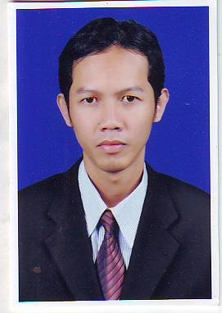
Personal Information
Full Name : Haris Susanto
Sex : Male
Place, Date of Birth : Bandung, 19 Juli 1981
Nationality : Indonesia
Status : Maried
Height, Weight : 173cm, 53Kg
Health : Excellent
Religion : Moeslem
Address : Komplek Pohon Mangga Regency
E.10 Rancamanyar-Kab Bandung
Mobile : 081223945314
Email : odes_jajaka@yahoo.com

Educational Background
2005 – 2009 : STMIK LPKIA Bandung
(Sarjana Teknik/Teknik Informatika)
2001 – 2003 : Quantum eCommerce College Bandung
( web Design )
1996 – 1999 : SMU Pasundan 3 Bandung
( IPA )
1993 – 1996 : SLTPN 24 Bandung
1987 – 1993 : SD Pasundan 3 Bandung

Course & Education
Juni 2011 : PEDFI Certification (GP Farmasi Indonesia)
2012 : Leadership Certification (MarkPlus Jakarta)

Work Experience
Jan 2013 – March 2018: PT Merck Sharp & Dohme Indonesia
( Professional Medical Representative Prod Pain & Metabolic )
Apr 2012 – Des 2012 : PT. Aardwolf Pestkare Indonesia
( Account Executive – Bandung )
2010 – Apr 2012 : Glaxo SmithKline Indonesia
( Profesional Sales Representative Prod Respiratory )
2008 – 2010 : PT. Sagi Capri Div NCV PT Tanabe Indonesia
( Medical Representative Prod Non Cardio )
2004 – 2008 : PT Coronet Crown Bandung
( Medical Representative )
1999 – 2004 : PT. Pensilindo Pratama Bandung
( ADM )
I declare that all information above is true and correct the best of my knowledge.
Best Regards,
Haris Susanto

