|  |
| --- |
| **CURRICULUM VITAE** |
| MUGGY BAKTY SETIA |
|  |
|  |
|  |
|  |
| **3/31/2018** |
|  |

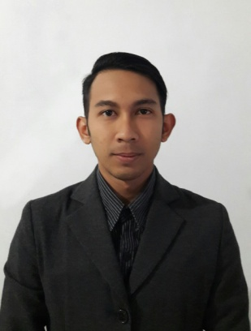Curriculum Vitae

**PERSONAL DETAIL**

Date of Birth : 10 july 1990

Age : 27 years old

Sex : Male

Religion : Moeslem

Marital status : Single

Skill language : Indonesia, English, sundanese

Interest : Travelling, Riding motorcycle, adventure,hiking.

Personal Statement : I’m good at communication. I can work together with other. I believe in my ability to do technical, administration , trainer.and I can quickly learn.

**EDUCATIONAL QUALIFICATIONS**

July 2010 : Technical academy at Yamaha engineering school

Juni 2008 : Graduated at SMKN 8 Bandung

**WORK EXPERIENCE**

* 2010 - 2012 : Technician at Yamaha Indonesia Motor Mfg
* 2013 – 2014 : Service advisor Yamaha Deta Jakarta
* 2014 – 2015 : Coordinator area service & sparepart Deta group Jakarta

( 6 network )

* 2015 – 2016 : Coordinator area service & sparepart Deta group Jabar

( 11 network )

**SKILLS**

* Engine technician
* Service advisor
* Trainer
* Computer Microsoft office, Corel draw, Corel video studio

**SERTIFICATE**

* **Technical skill contest first podium at HONDA**
* **Technical skill contest second podium at YAMAHA**
* **Sparepart management and system Yamaha level Bronze**
* **Sparepart management and system Yamaha level Silver**
* **Training to trainer level bronze and silver at Markplus institute**
* **Management training dealer and workshop Yamaha level Gold**