CURRICULUM VITAE
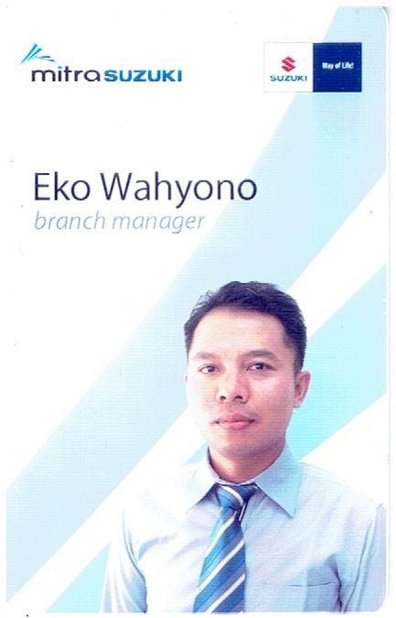

Name : Eko Wahyono, SE
Place of Birth : Balikpapan, September’ 29, 1976
Addres : Jl. Ampera KM 12 RT. 16 No. 16
Kelurahan Karang Joang, Balikpapan - Kaltim
Mobile : 0811 53 6238, 0816 67 6238
Email : al.dhekow.ew@gmail.com

Formal Education : - D1 Computer Accounting YPPSDM Dewi Sartika Yogyakarta
- S1 Accounting Department College of Economic UNIBA Balikpapan

WORKING EXPERIENCE
1. 2005 – 2011 : PT. Astra International, Tbk Toyota Sales Operation –
Branch Balikpapan Sudirman ( Senior Sales Executive & S. Co).
2. 2011 – 2015 : PT. Serba Mulia Auto – Tri Mandiri Group (Marketing & CR Manager).
3. 2015 – 2016 : PT. Mitra Suzuki Banjarmasin (Branch Manager).
4. 2016 – 2018 : PT. Agung Rent (A.M – Kalimantan, Sulawesi, Papua).

COURSES / TRAINING / EXPERIENCE
- Courses Computer Under Windows Program
- Education Painting Auto Refinish in PT. DANAPAINTS Indonesia Jakarta and Denso Product in PT. Denso Indonesia Corporation
- Delegation Balikpapan University for the STAN ALI WARDHANA Jakarta in CONTEST NATIONAL ACCOUNTING 2000
- Delegation Balikpapan University for the Gajah Mada Jogjakarta University in Lokakarya National
- Presidium Kalimantan Area The Forum Cruise Nationality & Taruna (Academy Militer & Police Indonesia).
- Achievement Motivation Training (AMT)
- Joint for Research Institution Balikpapan University in PBE Surveyor BAPPENAS, and Research in PT. Telkomsel Regional Kalimantan.
- Reword appreciation in recognition of valuable contributions to Garda Oto Liga Wiraniaga II 2005 from PT. Asuransi Astra Buana Jakarta
- Trainee in PT. Astra International, Tbk to First Salesmanship Training (FST)
- Trainee in PT. Toyota Astra Motor to Toyota Sales Profesional Development Program Level One “Basic Selling Skills training”, Level Two “Self Potential Development” and Level Three “Advanced Negotiation Skilss” (Gold Certificate)
- PT. Astra International – Daihatsu Sales Operation (Customer Relationship Management Forum)
- Training Leadership Mental Transformation by DCI-NLP
- Branch Manager Development Program (BMDP)

Balikpapan, Nopember’ 2018

EKO WAHYONO, SE

