**Steven Lindrasan**

Zamrud 1 wing III no 198 m, Ciwaruga 40559, West Java

087727304686, steven.lindrasan19@gmail.com

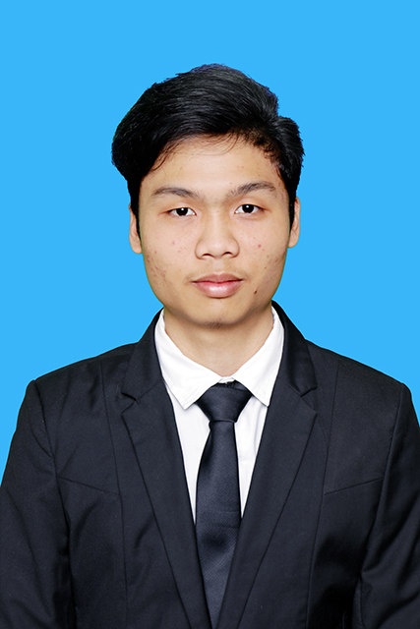

**EMPLOYMENT OBJECTIVE**

A career in Service Industry, specifically in the areas of Financial Analysis and Management that will optimally utilize good analytical skills, decision making, and problem solving skills.

**EDUCATION**

**INSTITUT TEKNOLOGI HARAPAN BANGSA**, Bandung, IndonesiaSept 2018

Sarjana Teknik Industri. Concentration: Industrial Engineering

**Certiplus Program** Dec 2017

at ITHB Career Resource Center

Completed a series of professional training in computer, communication, leadership,

entrepreneurship and career planning skills

**SAP University Alliance Program**

at ITHB Career Resource Center

Completed the Business Associate TERP10-SAP ERP Integration of Business Processes May 2017

Completed the SAP ERP Configuration using GBI May 2016

Completed the SAP Introduction to SAP ERP with Global Bike Incorporation V2.1 Dec 2015

**EXPERIENCE**

**PT. HEKSATEX INDAH**, Bandung, Indonesia May 2017 – Jul 2017

*One of the largest fabrics company producing nylon spandex, mesh, tulle, powernet, double knit, brokat, and wrapknitting. Heksatex provides and supplies various products to Nike, Adidas, Eiger, Disney, Emporio Armani, New Balance, Kalibre, surfer girl and many more in global market.*

Summer Intern, Human Resource and Development Department

Developed organizational structure for the company to increase revenue and improve efficiency and effectiveness of productions.

* Evaluated existing organizational structure PT. Heksatex Indah
* Conducted business process analysis PT. Heksatex to find company problems
* Created new organizational structure based on current business process

**Votum Production,** Bandung**,** IndonesiaSeptember 2016 - present

*A local business concern in photography, videography, and cinematography*

Chief Executive Officer and Founder

Organized operational activities, such as promotions, customer order receives, negotiation, order processing, and billing.

* Updated social media promotion content to increase the number of consumers
* Created videos and photos for various events like birthday party, sweet seventeen, travel, etc.

**Nextgen Bandung at GBI Sukawarna**,Bandung, Indonesia July 2016 - present

*The largest Christian church that served teens, youth and millennial generations.*

Chairperson, Development Unit

Developed and equipped leaders and workers with leadership skill, character and attitude training

* Organized and provided training event committee for all leaders and workers Nextgen Bandung
* Conducted leaders and workers training to develop leadership basic skill that involved more than 150 leaders

**ADDITIONAL INFORMATION**

* Highly proficient in the following technologies:
* Adobe Collections: Adobe Photoshop, Adobe Premiere Pro, Adobe Lightroom
* Office Suite: Ms. Word, Ms. Excel, Ms. Access, Ms. Power Point.
* Drawing Application: AutoCAD, Corel Draw, Promodel
* Completed pre-intermediate Global English course at TBI (1 June 2016).
* Achieved TOEFL Practice Test Score (August 2016): 477