Bandung, April 4, 2019

Dear,
Human Resources Manager
Honda IBRM, Bandung
Indonesia

To Whom It May Concern:
I am applying for a position as a Sales Executive in your company, Honda IBRM, as I feel my background will be of an interest to you. I was working in Food and Beverages field before, because of my education background. But, lately I am interested in working in automotive field, especially selling automotive products. I am a hard worker and easily learn new things.
Here is short resume about me:
Name : Joko Prawito
Date of Birth : Semarang, Oktober 11, 1989
Marital Status : Single
Last Education : Diploma 1 Basic Marine Hotel Operation and Services
Current Address : Jalan Sukarajin II Gang Haji Sobana IV No 9, RT 10 RW 12, Bandung
E-mail : joeprawito@gmail.com
Phone Number : 0821-3589-1256
Enclosed is my resume, which indicates in some details about my trainings and experiences. I sincerely hope that my qualifications are of interest to you and that an interview might be arranged at your convenience.
Thank you for your consideration. I look forward to hearing from you soon.
Sincerely yours,

Joko Prawito
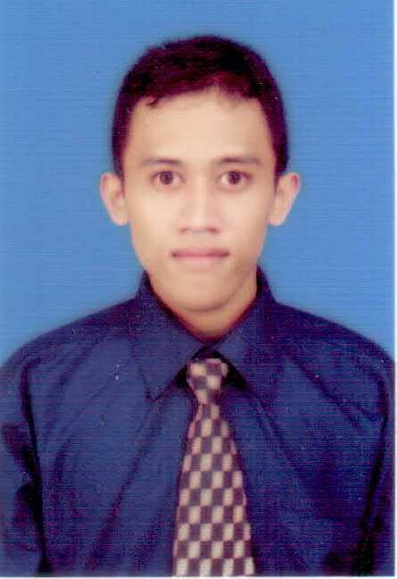
Curriculum Vitae

PERSONAL DATA
1. Full Name : Joko Prawito
2. Nick Name : Ito’
3. Date of Birth : Semarang, October 11, 1989
4. Sex : Male
5. Height/Weight : 160cm/ 50kg
6. Current Address : Jalan Sukarajin II Gang Haji Sobana IV No 9, RT 10 RW 12, Bandung
7. Hometown Address : Jalan Menoreh I/70A, RT 05/RW V, Semarang-50236
8. Marital Status : Single
9. Phone Number : 0821-3589-1256
10. E-mail : joeprawito@gmail.com

EDUCATIONAL BACKGROUND
A. FORMAL
- (2001) graduated from SD N Bendan Ngisor 01-02, Semarang
- (2004) graduated from SMP N 2 Demak
- (2007) graduated from SMA N 5 Semarang
- (2011) graduated from Diploma 1 Basic Course for Marine Hotel Operation and Services, Pacific Cruiser, Surakarta
B. NON FORMAL
- (2011) had a Job Training at Novotel Hotel, Mangga Dua Square, Jakarta
- (2012) had an English Conversation Program at Pacific Cruiser, Surakarta
- (2012) had a Basic Safety Training at Pertamina Maritime Training Center, Jakarta
- (2012) had a Basic Training for Messroom Attendant at ms Nieuw Jakarta
- (2015) a participant in a Course of Expresso Expert and Creative Coffee Class at Universita Del Caffe, Bandung
- (2017) a participant in a Ms Words and Ms Excel Class at Alfabank, Semarang

WORKING EXPERIENCES
- Holland America Line Cruise Ship, Seattle
Period : February 2013 to December 2013
Position : Messroom Attendant
Job Description : Serving food and beverages for all crew members, maintaining cleanliness of working place.
- ‘B’ Coffeehouse and Eatery, Bandung
Period : February 2015 to September 2015
Position : Barista
Job Description : Making all kinds of beverages for customers, maintaining cleanliness of coffee machine, grinder, and all parts.
- Stove Syndicate, Semarang
Period : December 2017 to December 2018
Position : Head Waiter
Job Description : Taking orders from the customers and giving a suggestion for them, Up Selling products, Handling Complaints, Making the schedules for the other Waiters, Maintaining the cleanliness of working place.

SKILLS
- English Writing and Basic Conversation
- Ms Words and Excel
- Selling Products
- Basic Safety

