**Kepada Yth,**

**HRD / PERSONALIA**

**Di Tempat**

Dengan hormat,

Saya yang bertanda tangan di bawah ini :

|  |  |  |
| --- | --- | --- |
| Nama | : | Benatri Gala Ardhan |
| Tempat, Tgl. Lahir | : | Serang, 24 April 1990 |
| Alamat | : | Komp. PCI Blok B.26 |
|  |  | No.19 001/005 Cibeber – Cilegon, Banten 42422 |
| No. Telp / HP | : | 0852 1191 0101 |
| Pendidikan | : | S1 Akuntansi Universitas Sultan Ageng Tirtayasa |

Bersama ini saya ingin mengajukan permohonan pekerjaan pada perusahaan yang bapak/ibu pimpin, kiranya pendidikan di Universitas Sultan Ageng Tirtayasa dapat saya jadikan bekal sekaligus dukungan untuk terampil bekerja dan beradaptasi pada bidang pekerjaan.

Besar harapan saya atas terkabulnya permohonan ini untuk menjadi pegawai/karyawan bapak/ibu, bergabung mengabdi mengejar kesuksesan bersama. Dengan ini pula saya sertakan data pendukung.

Atas perhatian, bantuan, kesempatan yang diberikan serta kerjasama yang baik disampaikan terimakasih.

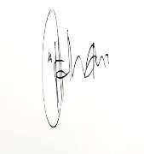

Hormat saya,

Benatri Gala Ardhan

|  |  |  |  |  |  |  |
| --- | --- | --- | --- | --- | --- | --- |
|  |  |  | **C U R R I C U L U M V I T A E** | | |  |
|  |  |  |  |  |  |  |
|  |  |  | **P E R S O N A L D E T A I L S** | | |  |
|  | **Full Name** |  | Benatri Gala Ardhan | |  |  |
|  |  |  |  |  |  |  |
|  | **Place / Date of** |  | Serang, 24 April 1990 | |  |  |
|  | **Birth** |  |  |  |
|  |  |  |  |  |  |
|  |  |  |  |  |  |  |
|  | **Gender** |  | Male | |  |  |
|  |  |  |  |  |  |  |
|  | **Nationality** |  | Indonesia | |  |  |
|  |  |  |  |  |  |  |
|  | **Religion** |  | Moslem | |  |  |
|  |  |  |  |  |  |  |
|  | **Marital Status** |  | Singel | |  |  |
|  |  |  |  |  |  |  |
|  | **Current Address** |  | Komplek PCI Blok B26 No.19 Rt 001/005 Cilegon, Banten 42422 | | |  |
|  |  |  |  |  |  |  |
|  | **Phone** | 085211910101 | |  |  |  |
|  |  |  |  | | |  |
|  | **Email** |  | [benardhan24@gmail.com](mailto:benardhan24@gmail.com) | | |  |
|  |  |  |  |  |  |  |



**E D U C A T I O N A L** **B A C K G R O U N D**



|  |  |  |  |  |  |
| --- | --- | --- | --- | --- | --- |
| **Period** | **Institutions** | **City** | **Major** | **Grade** |  |
| 1996 – 2002 | National Elementary School | Cilegon |  |  |  |
| Kedaleman 4 Cilegon |  |  |  |
|  |  |  |  |  |
|  |  |  |  |  |  |
| 2002 - 2005 | National Junior High School 5 | Cilegon |  |  |  |
| Cilegon |  |  |  |
|  |  |  |  |  |
|  |  |  |  |  |  |
| 2005 – 2008 | National Senior High School 3 | Cilegon |  |  |  |
| Cilegon |  |  |  |
|  |  |  |  |  |
|  |  |  |  |  |  |
| 2008 – 2014 | Sultan Ageng Tirtayasa Universitty | Cilegon | Accounting | 2.85 |  |

|  |  |
| --- | --- |
|  | **O R GA N I Z A T I O N** |
| **Period** | **Organization** |
| 2008 – 2010 | Member of Front Aksi Mahasiswa (FAM) |
| 2008 – 2011 | The Treasurer of Himpunan Mahasiswa Jurusan Akuntansi |
| 2011 – 2013 | The Treasurer of Badan Eksekutif Mahasiswa Fakultas Ekonomi |
|  |  |

**S E M I N A R S & T R A I N I N G**



**Year** **Seminar and Training**

**E M P L** Member Of Seminar Sistem Akuntansi Keuangan

**O Y M E** Member Of Training New Teller Programme for Mikro at PT. Bank CIMB

**N T H I** NIAGA TBK

**S T O R**



**E M P L O Y M E N T H I S T O R Y**

1. ADM Collection at PT. Permata Finance Indonesia in 2013
2. Internal Audit at PT. Arwana Citra Mulia TBK in 2014
3. Teller at PT. Bank CIMB NIAGA TBK in 2015
4. Marketing Executive at CIPUTRA in 2016 - 2017
5. Project Finance at Gemilang Karya Mandiri in 2018 ( Maluku )

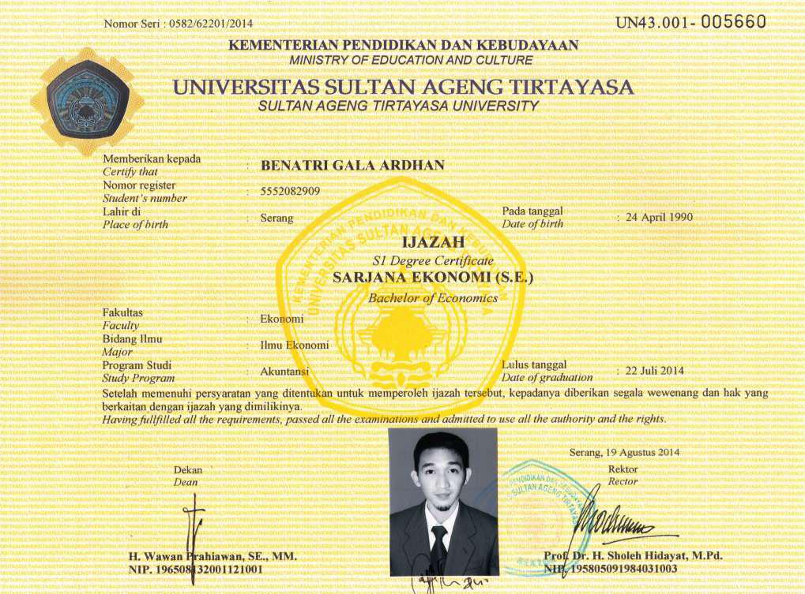

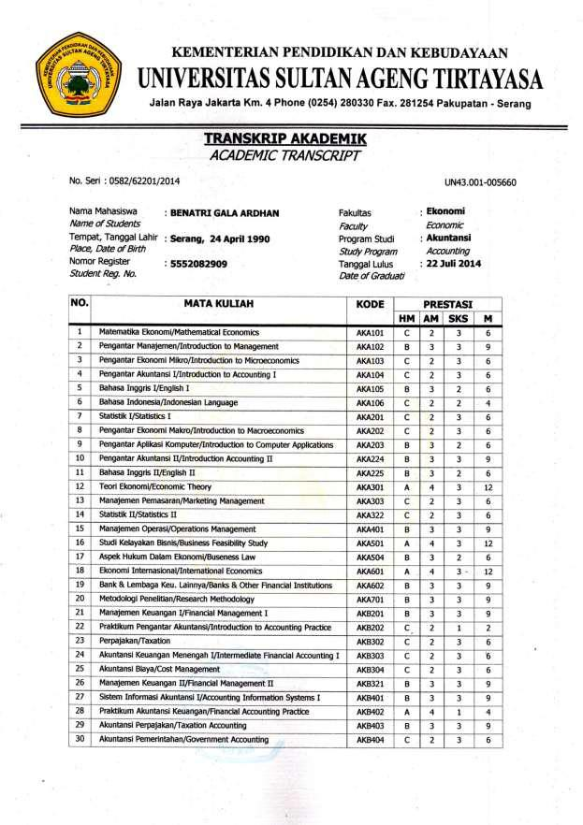

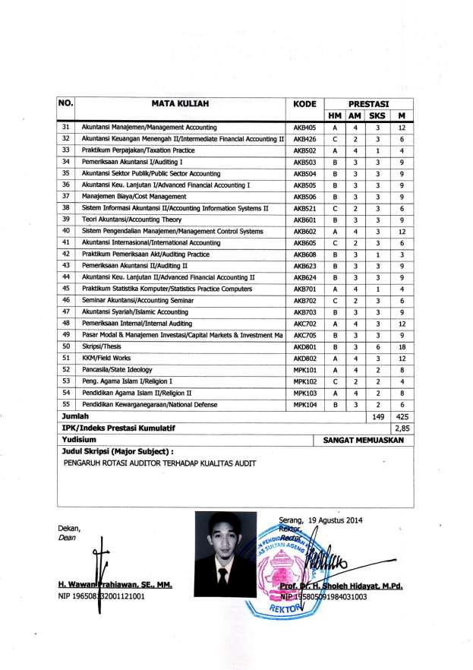

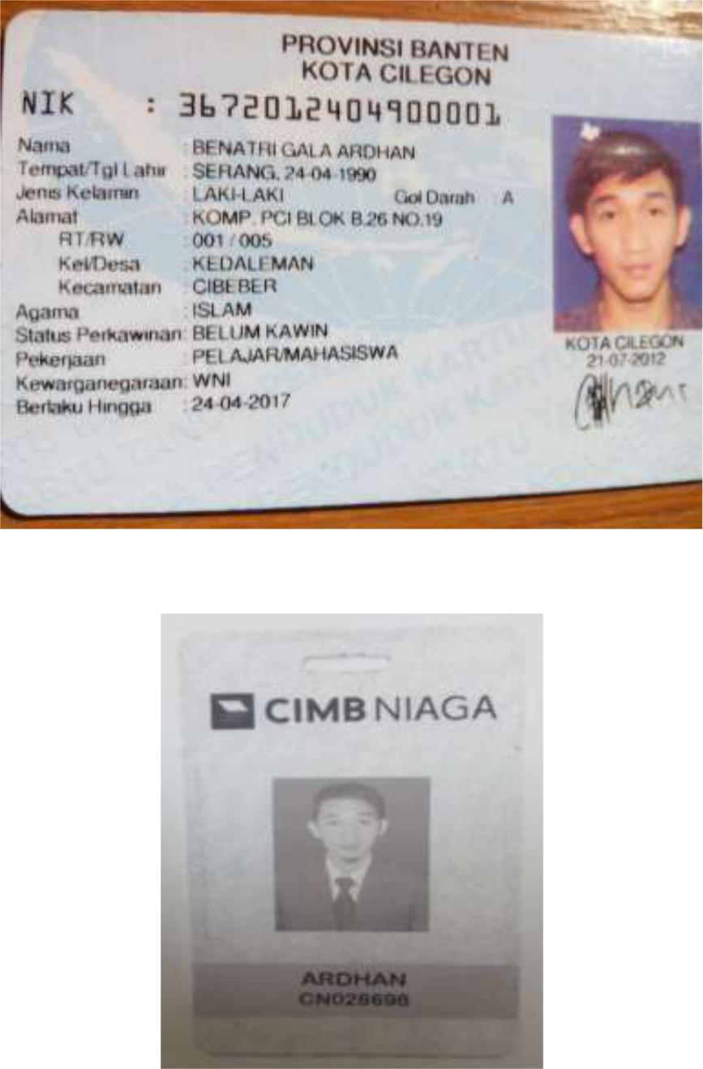

017&/IV-St\1.TD 11·201S **liiJCIMB** NIAGA

Certificate of Completion to

**Benatri Gala Ardhan**

*NIK No: CN028698*

To certifiy that He has completed



New Te Progra

,

**Mariana** ulaiman

N•llonal !lead Servlee A<•d•m)

