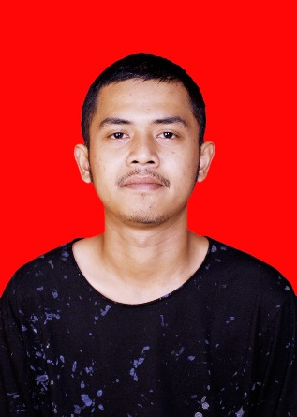

Raka Nur Ilham

CV

|  |  |  |
| --- | --- | --- |
| Data Diri  Name: Sukagalih street Gg. Sukabakti 2 no 24 Rt. 08 Rw. 06  Gender: Male  Born: Bandung, 05 Maret 1997  Status: Single  Email: rakachinomuffins@gmail.com  No Telp : 6281395359839    Education  **SDN Sukagalih 6 Bandung.**  2003–2009  **SMP Negeri 26 Bandung** 2009–2012  **SMK Angkasa Lanud husein** 2012-2015  Skills  Microsoft Word ⮚⮚⮚⮚⮚⮚⮚⮚⮚⮚  Microsoft Exel ⮚⮚⮚⮚⮚⮚⮚⮚⮚⮚  Basic Internet ⮚⮚⮚⮚⮚⮚⮚⮚⮚⮚  Administration ⮚⮚⮚⮚⮚⮚⮚⮚⮚⮚  Documentary ⮚⮚⮚⮚⮚⮚⮚⮚⮚⮚  English language ⮚⮚⮚⮚⮚⮚⮚⮚⮚⮚ |  | Experience  PT Mitra Adiperkasa  *Sales Assistant*  05 Maret 2016 – 29 November 2017  A company retail fashion branded ZARA   * *Customer Service* * *Image Maintance* * *Good of sales.* * *Stock good on the floor.* * *Cleanliness and tidiness* |

Curriculum Vitae  ~~-~~