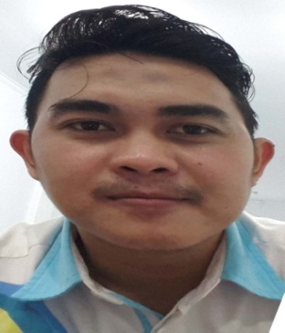

GHULAM FARIS SYAIFUL H, SE

CV

|  |  |  |
| --- | --- | --- |
| Personal Details  Addres : Jl. Cipaku RT 02/01 kel, Cibogo Kab, Subang  Gender : Male  Place & Date : Bekasi, 16 Oktober1988  of Birth    Marital Status : Married  Email : [Gfaris444@gmail.com](mailto:Gfaris444@gmail.com)  Education  Bachelor Degree of Economic (Accounting)  *Sekolah Tinggi Ilmu Ekonomi Sutaatmadja Subang (STIESA) -* December 2011  Other Skills  Microsoft Word  Microsoft Exel  English lenguage  Accounting  Sales & Marketing  *Leader Open Turnamen Futsal 2009&2010  *Leader bazar UKM Subang 2010  *Leader bazar mizzan 2010 |  | Experience  PT. Astra International, Tbk  Marketing and Sales executive  2014 – 2017  A company specialized in automotive.   * Product Sales. * Product Consultans.   CV. Darwin  Owner  2007 - 2014  A company specialized in snack foods.   * Managerial and development * Determine the division of team task. * Product marketing.   Costumer Service  PT BCA Tbk  2012 – 2013  A company specialized in banking.   * As a costumer service. * Costumer Complaints   Award and Achievements  POPDA Futsal Subang Player 2009  Chairman of the association accounting student 2009  Mamber of BEM STIESA Subang 2010  3rd Futsal Tournament at STIESA Subang 2010  Runner up Futsal Tournament at Astra Daihatsu 2012  Licence Coach Trainning Futsal Level 1 National 2017  Winner Futsal Tournament at Disdikbud 2018 |

Curriculum Vitae~~-~~