**CURRICULUM VITAE**

**DATA DIRI**

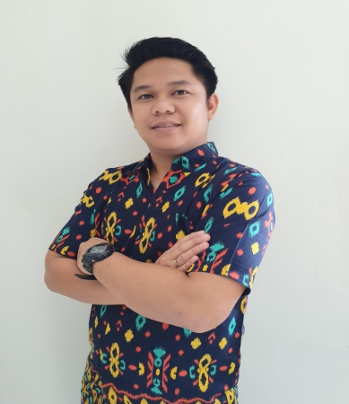Nama : Yuki Rusnandi

Tempat, TanggalLahir : Karawang, 7 Mei 1988

JenisKelamin : Laki-laki

Agama : Islam

Alamat : PerumGempolPermai No 21 RT 02/01

TanjungpuraKarawangBarat Karawang 41316

Handphone : 081286793337

Status : Menikah

Email : [yuki.rusnandi@gmail.com](mailto:yuki.rusnandi@gmail.com)

**PENDIDIKAN**

2003-2006 SMAN 3 Karawang

2007-2011 UniversitasGunadarma (S1 TeknikInformatika)

**PENGALAMAN**

OTO Multiartha **Desk Coll,** Jakarta (Part Time selama 3 bulan)

Asuransi JiwaSinarmas **Financial Advisor,** Jakarta (selama 9 bulan)

BCA Finance **Credit Marketing Officer**, Karawang (2012-2018)

**Branch Manager**, Parepare (2018 – sekarang)

**PENCAPAIAN**

BCA Finance 15 High Achiever National Trip to Cruise Ship Singapore (2014)

High Achiever CMO Trip to Singapore 2015

High Achiever CMO Trip to Malaysia 2016

High Achiever CMO Trip to Lombok 2017

High Achiever Branch Manager trip to Bangkok 2020