CURICULUM VITAE

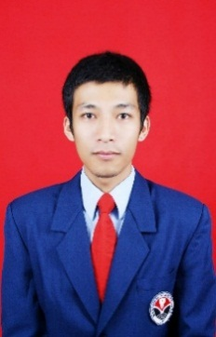

PERSONAL DETAIL

* Nama : Sendy Suarsa
* Place and Date of Birth : Bandung, 1 Desember 1985
* Marital Status : Single
* Adrres : Gg Rahayu 1 No 7 Bandung 40184
* Email : [nazwaina@ymail.com](mailto:nazwaina@ymail.com) / sendynazwaina@gmail.com
* Phone : 087830070041
* Weight : 60 Kg
* Height : 172 Cm

EDUCATION

* S1 in Menejemen industri katering Food and Beverage

Universitas pendidikan indonesia - Bandung

2006 to 2012

* Food and Beverage ( Tata Boga )

Smk shandy Putra Bandung ( Telkom School ) - Bandung

2004 to 2006

WORK EXPERIENCE

* Sales consultant PT Honda Autobest Bandung
* Supervisor Labbaik Chiken Cabang Kebon Kopi - Desember 2016 to 2018
* Jr Supervisor Pt Indowisata Permata - October 2015 to September 2016
* Captain Crew Pt Reska Multi Usaha Bandung - April 2013 to October 2015

Pengawas Restorasi Kereta Api

* Captain Crew Pt Buana Daya Anugrah Bandung - June 2012 to September 2012
* On Job Training Food and Beverage Service Ancasa Hotel & Resto Kuala Lumpur - April 2009 to September 2009 In job training