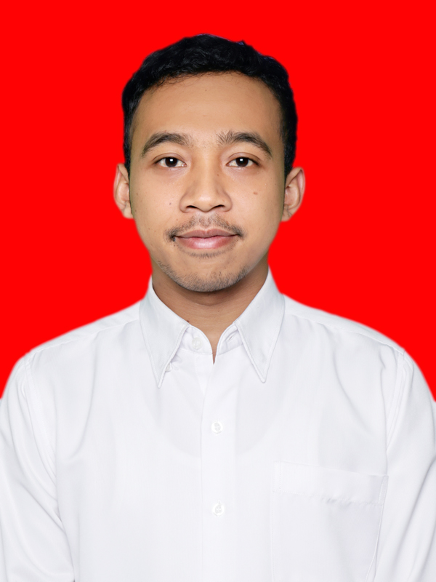**CURRICULUM VITAE**

|  |  |
| --- | --- |
| **PERSONAL PARTICULARS** | |
| Full Name | Farhan Muqaffi, S. Par. |
| Address | Komp. Polri No. 15 Jalan Sukagalih I Sukajadi Bandung Postal Code: 40162 |
| Phone Number | 0821 2000 8699085721934563 |
| E-Mail | farhanmuqaffi@yahoo.co.id[ilham_fajri@ymail.com](mailto:ilham_fajri@ymail.com) |
| Religion | Islam |
| Nationality | IndonesiaIndonesia |
| Date of Birth  *(DD-MM-YYYY)* | 23 - 08 - 199004-03-1988 Place of Birth: Bandung |
| Marital Status | Married |
| Sex | Male |
| Height | 168 cm |
| Weight | 70 kg |

|  |  |  |
| --- | --- | --- |
| **EDUCATION BACKGROUND** | | |
| **School** | **Year** | **Qualification Obtained** |
| SD Al-Muttaqin Tasikmalaya | 1997-2003 | STTB |
| SMP Al-Muttaqin Tasikmalaya | 2003-2006 | Ijazah |
| SMAN 1 Tasikmalaya | 2006-2007 | - |
| SMA Al-Muttaqin Tasikmalaya | 2008-2009 | Ijazah |
| Sekolah Tinggi Pariwisata Bandung  (Basic Language Training) | 2009-2009 | Certificate |
| Manajemen Patiseri STP Bandung | 2009-2010 | - |
| S1 Manajemen Industri Katering UPI Bandung | 2010-2015 | Ijazah |

|  |  |  |  |
| --- | --- | --- | --- |
| **COURSE & PARTICIPATION** | | | |
| **Position** | **Name of Activities** | **Year** | **Qualification Obtained** |
| Participant | Table Manner The Papandayan Hotel | 2011 | Certificate |
| Indonesian Contigent | Chingay Parade 40th Anniversary. Singapore | 2012 | Certificate |
| Participant | Lessons For Life (English Course) | 2012 | Certificate |
| Committee | International Seminar of Gastronomy (The Strengthening of Traditional Food & Beverage as Tourism Attraction). MIK FPIPS UPI. | 2013 | Certificate |

|  |  |  |  |  |  |  |
| --- | --- | --- | --- | --- | --- | --- |
| **LANGUAGE / DIALECTS & OTHERS SKILLS** | | | | | | |
| **LANGUAGE** | **SPOKEN** | | | **WRITTEN** | | |
| Excellent | Good | Fair | Excellent | Good | Fair |
| English |  | **X** |  |  | **X** |  |
| **Achievement:**   * Top Showing Property 2017 – Sadewa Propertindo. * Help the owner of property to rent and sell house, apartment and building at Setrasari, Cihampelas Street, Majesty Apartment etc.   **Computer:**   * MS. Office, MS. Excel, Ulead Video Studio dan Internet.   **Hobby:**   * Learning English. * Traveling. * Culinary. * Sports (Hiking, Basket and Futsal or Football). | | | | | | |

|  |  |  |  |
| --- | --- | --- | --- |
| **EMPLOYEMENT HISTORY** | | | |
| **Periode** | **Name and Location of Company** | **Position Held** | **Reason For Leaving** |
| Juli 2017 - Juli 2018 | PT. Sadewa Sukses Makmur (Jl. Setiabudi No. 8 Bandung) | Marketing Staff - Property | Get Another Job |
| Desember 2018 | PT. Anugerah Pharmindo Lestari a Member of Zuellig Pharma | Merchandiser | Contract |
| Januari 2018 - Now | PT. Anugerah Pharmindo Lestari a Member of Zuellig Pharma | Field Sales Representative – Darya Varia Laboratoria Exclusive | Get Another Challenge Job Opportunity |

|  |  |  |  |
| --- | --- | --- | --- |
| **GENERAL & DECLARATION** | | | |
|  | **No** | **Yes** | **If Yes, Give Particulars** |
| Have you ever been convicted in a court of law | **X** |  |  |

I declare that the information in these curriculum vitae are true.

Sincerely,

Farhan Muqaffi