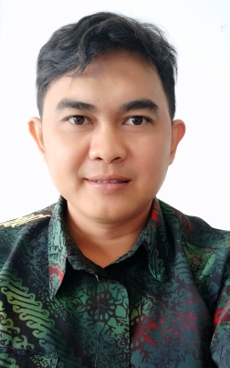  Profile  I am a hard worker who is able to work under pressure, I work with a target focus so that the achievement targets given by the company are achieved.  even though I graduated in accounting but I am able to work for management and finance both within the company and outside the company.  My soft skills and hard skills are the result of my work experience and educational background  Contact  PHONE:  081-8090-9294-8  EMAIL:  Gfaris444@gmail.com  Hobbies  Football  Futsal  Musik |  | ghulam faris syaiful hayat, se  EDUCATION  SEKOLAH TINGGI ILMU EKONOMI SUTAATMADJA SUBANG (STIESA)  2007 - 2011  Bachelor Dagree of Economic (Accounting)  GPA 3.18  WORK EXPERIENCE  PT lider Bahtera Toolsindo (Team leader Marketing)  2020 Desember – Now  A company specialized Developer KPR and Comersil  -Approval to bangking  -Make content sales team to target focus  PT Cahaya Raudhah (Team Leader Telemarketing)  2018 Desember – 2020 April  A company specialized Umroh & Haji  -Telemarketing social media  -Make content to sales  PT ASTRA INTERNATIONAL Tbk (Marketing & Sales Consultant)  2014 Maret – 2017 Maret  A company specialized in automotive.  -Product Sales  -After Sales  PT BANK CENTRAL ASIA Tbk (Costumer Service Officer)  2011 April – 2012 April  A company specialized in banking.  -As a costumer service.  -Costumer Complaints  SKILLS

