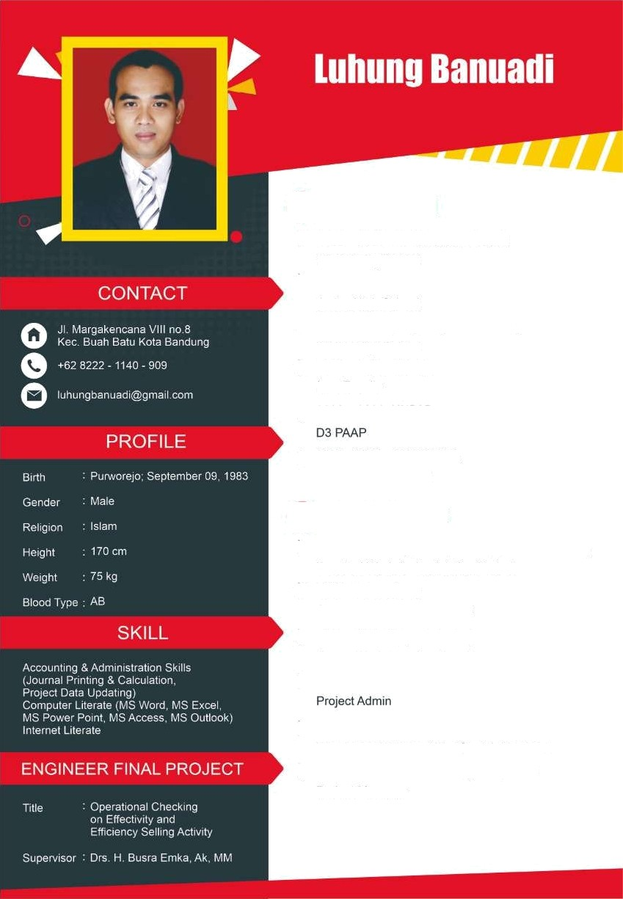

**EDUCATION**

* 1989 — 1995 SD Sutogaten Pituruh Elementary School
* 1995 — 1998 SMP Negeri 1 Kutoarjo

Junior High School

* 1998 — 2001 SMU Negeri 3 Bandung

Senior High School

* 2001 —2002 UNPAD

Law Faculty

* 2002 — 2006 UNPAD

D3 PAAP

* 2006 - 2008 STIE INABA

Accounting Economy

**EXPERIENCE**

* 2009 - 2012 Nissan Sokearno Hatta

**Sales Executive**

* 2012 - 2013 Tunas Toyota Gatsu

**Sales Executive**

* 2013 – 2016 Honda Pasteur

**Sales Executive**

* 2016 - 2017 Honda Sonic **Sales Executive**
* 2018 – 2021 PT. Adhikarya (Persero)

**Procurement**

* 2023 – Sekarang Suzuki NJS Buahbatu

**Sales Supervisor**